Accountancy Interview Preparation Worksheet 2022

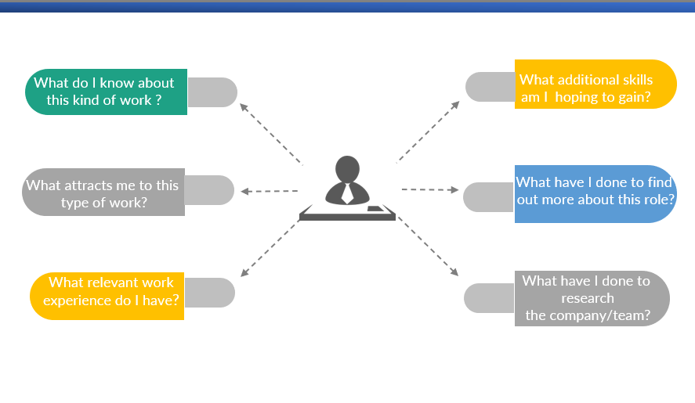

Interview Preparation Worksheet- Accountancy

Tell us about yourself and why you want this role:
The recruiter is really asking is why should they hire you so use this opportunity to give a brief explanation of your career story to date that will highlight relevant experience and how you match the role. Break the answer into 4 sections:
- Your education: As a graduate you may like to start with your degree and why you chose this career area or you can start from school and explain how you are now in the final year.
- Your skills and accomplishments in relation to the role: Focus on the skills you have or any accomplishments you have that tie in with the skills or competencies they are looking for.(sports, working part time while studying, exemptions, customer service )
- Work Experience: highlight how your work experience has developed the skills you need for this role- time management, initiative etc
- Finish Strong: Finish strong by explaining why you want THIS role with THIS company.

Keep it to 2 minutes max
___________________________________________________________________________________________________________________________________________________________________________________________________________________________________________________________________________________________________________________________________________________________________________________________________________________________________________________________________________________________________________________________________________________________________________________________________________________________________________________________________________________________________

Why this company/ What do you know about us? You need 3-4 specific pieces of information on the company that demonstrates that you have properly researched THIS company and want a job in THIS company. It is not enough to say they are a big company with great training! Look at their graduate careers page – they are likely to have brochures, videos etc. They will also have social media pages. You may have seen them at an employer event.
What is attractive about them specifically e.g. career progression, training, values, culture, varied experience, travel overseas, leading edge technology, innovation, market position, the people you have met, employer presentations you attended. Further assistance on researching a company.
Watch employer presentations here: https://mymoodle.ncirl.ie/course/view.php?id=1436
_____________________________________________________________________________________________________________________________________________________________________________________________________________________________________________________________________________________________________________________________________________________________________________________________________________________________________________________________________________________________________________________________________________

Why this role? You need to look at why you want this role specifically. So having researched accounting, audit or tax what is it specifically that interesets you about it. Look at the bullet points on the spec and where you feel you would add value to them. Look at people doing the job on LinkedIn and see how their career has progressed. Show how you have researched the role and know it is for you – met representatives at careers fairs, spoke to people doing the role, did an internship etc. YOU NEED TO BE SPECIFIC!!! Know your exemptions!!!!

___________________________________________________________________________________________________________________________________________________________________________________________________________________________________________________________________________________________________________________________________________________________________________________________________________________________________________________________________________________________________________________________________________________________________________________________________________________________________________________________________________________________________

Why are you interested in audit? Think behind the reasons you have chosen audit as your first preference.
- It might be that working in practice you will get exposure to a number of different clients and industries so you get to see how a number of different businesses and industries operate and the issues that affect them.
- As a trainee you will deal with clients who vary enormously in their operations, their controls, their size and structure and their commercial attitudes therefore you will gain broad business knowledge.
- Once you qualify in audit you will be advising businesses on their strategy and growth opportunities – very much a business advisor and will develop comprehensive knowledge about what is occurring and close relationships with key decision makers, and will be called upon to offer strategic advice.
- As an audit trainee, your role will typically involve analysing and interpreting facts and figures, offering advice to clients about improving their businesses, producing annual company financial statements and preparing reports.,
- Early responsibility: When you first join a practice you will be working within a team, but within a year or two you may be supervising staff and you will have to manage theirs and your work load. After two to three years you will be running jobs and managing the day to day relationship with the client,
- As every company is different, every audit is different and as a result every day is different/ Each week and day will be different from the other due to the diversity of tasks involved/ issues you will come across/ There are no typical days or weeks; they all present different challenges and opportunities.

- Why ACA ?
  - ACA Podcasts- https://www.charteredaccountants.ie/Prospective-Students/About-Chartered-Accountancy/become-a-chartered-accountant-podcast-series
  - 5 reasons to become a Chartered Accountant: https://www.charteredaccountants.ie/Prospective-Students/About-Chartered-Accountancy/5-Reasons-to-Become-a-Chartered-Accountant
  - ACA Training Contract: https://www.charteredaccountants.ie/Prospective-Students/Entry-Routes/Training-Contract
  - Inside Careers: Guide to Chartered Accountancy https://www.accountancycareers.co.uk/wp-content/uploads/Accountancy-Careers-202122-Online-Guide-Single-Pages_Reduced.pdf
  - Irelands Top 20 Accountancy & Business Advisors. Managing Partners in Ireland’s top Accountancy & Business Advisory firms discuss the Covid-19 impacts on their business and their clients - https://bizplus.ie/wp-content/uploads/2021/04/Accountancy-2021.pdf
  - Restructuring & Insolvency Advice 2020. Ireland’s Top Tax Advisers 2020
  - https://gradireland.com/careers-advice/accountancy-banking-and-finance/fyi-michelle-mulligan-audit-assurance
  - https://gradireland.com/careers-advice/accountancy-banking-and-finance/eamonn-grant-audit-assurance-trainee
  - Max Carroll, Audit Trainee, Mazars, https://www.youtube.com/watch?v=rxuRBPfyves
  - My Career in Audit: Aisling Branigan, Audit Assistant, Deloitte- https://www.youtube.com/watch?v=nnhnsz5zHao
  - My Career in Assurance: Caoimhe Cleere, Assurance Associate, PwC, https://www.youtube.com/watch?v=8ZzpMyAchkc
  - My Career in Audit: Niamh Fox, Audit Senior, EY, https://www.youtube.com/watch?v=QXP4DLE6d1E
  - My Career in Audit: Andrew McAteer, Assurance Associate, PwC https://www.youtube.com/watch?v=zgJE4yy81DA

Banking & Industry Career Profiles;
- My Career in Accountancy: Ruth Brady, Financial Management Accountant, Bank of Ireland https://www.youtube.com/watch?v=D94klDopbRU
- My Career in Accountancy: Kevin Lennon, Financial Operations Accountant, Mars- https://www.youtube.com/watch?v=fldq8sgNdxA

Why are you interested in Tax?
- Irelands Top 20 -Tax Advisors 2020 -https://bizplus.ie/wp-content/uploads/2020/10/Tax-Advisers-2020.pdf
- Exemptions: https://taxinstitute.ie/wp-content/uploads/2020/10/CTA-Course-Information-and-Regulations.pdf
- Graduate videos on a career in tax:
  - https://gradireland.com/careers-advice/accountancy-banking-and-finance/fyi-aaron-gallagher-tax-trainee-bdo
  - https://gradireland.com/careers-advice/accountancy-banking-and-finance/fyi-niamh-parsons-tax-associate-ey
  - https://gradireland.com/careers-advice/accountancy-banking-and-finance/hannah-gowdy-tax-consulting-trainee-kpmg
  - Aoife Bergin, Tax Trainee, BDO , https://www.youtube.com/watch?v=DT2dnabdYEM
  - My Career in Tax: Danielle McCullagh, Corporate Tax Associate, Deloitte, https://www.youtube.com/watch?v=vpxjX0ml1oo
  - My Career in Tax: Rebecca Byrne, Tax Associate, PwC- https://www.youtube.com/watch?v=c9WGU1ZTaAw
- https://www.researchgate.net/publication/5146973_The_Most_Popular_Tax_in_Europe_Lessons_from_the_Irish_Plastic_Bags_Levy
- New taxes being considered as Government bid to reduce plastic use https://www.breakingnews.ie/ireland/new-taxes-being-considered-as-government-bid-to-reduce-plastic-use-950989.html

Can taxation change behaviour and influence business? https://www.futurelearn.com/courses/public-financial-management/0/steps/14711

What Can You Expect From a Career in Tax? https://www.brightnetwork.co.uk/career-path-guides/accounting-audit-tax/career-in-tax/

How tax impacts taxpayer behaviour (PDF) - Slaughter and May https://www.slaughterandmay.com/media/2308010/how-tax-impacts-taxpayer-behaviour.pdf

About: Why work in tax? https://www.insidecareers.co.uk/career-advice/why-work-in-tax/

What are your exemptions? You absolutely need to know your exemptions for ACA, ACCA, CPA, CIMA or Tax depending on what you are applying for – See below although you will need to chek yourself as these may change!
ACCA: Exemptions -https://www.accaglobal.com/ie/en/help/exemptions-calculator.html
ACCA Exams: https://www.accaglobal.com/gb/en/student/getting-started/acca-qualification-structure.html
ACA Exemptions: https://www.charteredaccountants.ie/Prospective-Students/Apply-and-Join/Exemptions/NCIBAA
ACA Exams: https://www.charteredaccountants.ie/Prospective-Students/Course-description
CPA Exemptions: https://www.cpaireland.ie/Become-A-Student/Exemptions/Courses/Exemptions-Results?col=27&cou=108
CPA Syllabus: https://www.cpaireland.ie/CPAIreland/media/Education-Training/Syllabus%202021/syllabusFeb21_1.pdf
Tax Institute Exemptions: https://taxinstitute.ie/wp-content/uploads/2019/02/CTA-Course-Information-and-Regulations_2018_Online-1.pdf
CIMA Exemptions: https://www.cimaglobal.com/Starting-CIMA/Starting-CIMA/Exemptions/Exemption-Search/National-College-of-Ireland-NCI-9555/

_________________________________________________________________________________________________________________________________________________________________________________________________________________________________________

Tell me about your degree/ favourite subjects. Opportunity to sell the degree, the subjects and the college to employers. Makes sense to highlight subjects that are relevant to the role you are applying for.
_____________________________________________________________________________________________________________________________________________________________________________________________________________________________________________________________________________________________________________________________________________________________________________________________________________________________________________________________________________________________________________________________________________

Why Choose National College of Ireland/ Was it your first CAO choice? You need to demonstrate that you thought about where you were applying to and then achieved the goal. See the reasons why you chose NCI- modules, class sizes, links with industry etc
_________________________________________________________________________________________________________________________________________________________________________________________________________________________________

Were you happy with your leaving cert results? Why did you choose your leaving cert subject? These are questions that are frequently asked at graduate interviews. You need to have answers prepared about you did or did not pick certain subjects e.g. if you did not do accounting for the leaving but choose to do it for a degree what prompted that decision. If you were not delighted with your results you need to phrase it carefully and not lay the blame elsewhere – focus on the fact that with improved time management/ different study techniques etc your results have improved. If you were happy with you results – do not be afraid to say yes they got you exactly what you wanted in terms of College course etc.
_________________________________________________________________________________________________________________________________________________________________________________________________________________________________

Talk us through your college results (You will need to know these and your exemptions in detail.)
_________________________________________________________________________________________________________________________________________________________________________________________________________________________________

What have you gained from your degree/certificate? Things to focus on include subject knowledge if relevant to job – e.g. financial accounting, management accounting. Exemptions from the ACA/ACCA/CIMA/AITI exams. Transferable skills e.g. problem-solving, critical thinking, research skills, teamworking, communication, leadership skills etc
_________________________________________________________________________________________________________________________________________________________________________________________________________________________________

Competency Questions

You will match these questions to the skills/competencies required section in the job spec –
Answering Competency Questions – Advice from PwC & KPMG https://www.youtube.com/watch?v=HsMJEvs5B8E&list=PL1C21DFE1FA4AF7F0&index=3
More videos below!

Tell me about a time you worked to achieve a target, how did you go about it?
Situation: ______________________________________________________________________________________________________________________________________________________________________________________________________________________________________________________
Task: ______________________________________________________________________________________________________________________________________________________________________________________________________________________________________________________
Action: ________________________________________________________________________________________________________________________________________________________________________________________________________________________________________________________________________________________________________________________________________
Result: ______________________________________________________________________________________________________________________________________________________________________________________________________________________________________________________

Tell me about a time you had to persevere to achieve something?

Situation: ________________________________________________________________________________________________________________________________________________________________________________________________________________________________________________________________________________________________________________________________________________________________________
Task: ______________________________________________________________________________________________________________________________________________________________________________________________________________________________________________________________________________

Action: ________________________________________________________________________________________________________________________________________________________________________________________________________________________________________________________________________________________________________________________________________________________________________
Result: ______________________________________________________________________________________________________________________________________________________________________________________________________________________________________________________________________________

Tell me about a time you had to influence someone to your way of thinking

Situation: ________________________________________________________________________________________________________________________________________________________________________________________________________________________________________________________________________________________________________________________________________________________________________
Task: ______________________________________________________________________________________________________________________________________________________________________________________________________________________________________________________________________________

Action: ________________________________________________________________________________________________________________________________________________________________________________________________________________________________________________________________________________________________________________________________________________________________________
Result: ______________________________________________________________________________________________________________________________________________________________________________________________________________________________________________________________________________
______________________________________________________________________________

Tell me about a time you built a relationship with a customer

Situation: ________________________________________________________________________________________________________________________________________________________________________________________________________________________________________________________________________________________________________________________________________________________________________
Task: ______________________________________________________________________________________________________________________________________________________________________________________________________________________________________________________________________________

Action: ________________________________________________________________________________________________________________________________________________________________________________________________________________________________________________________________________________________________________________________________________________________________________
Result: ______________________________________________________________________________________________________________________________________________________________________________________________________________________________________________________________________________

Tell me about a time you exceeded a customers expectations
Situation: ________________________________________________________________________________________________________________________________________________________________________________________________________________________________________________________________________________________________________________________________________________________________________
Task: ______________________________________________________________________________________________________________________________________________________________________________________________________________________________________________________________________________

Action: ________________________________________________________________________________________________________________________________________________________________________________________________________________________________________________________________________________________________________________________________________________________________________
Result: ______________________________________________________________________________________________________________________________________________________________________________________________________________________________________________________________________________

Tell me about you failed at something or experienced a setback and what you did to overcome it.
Situation: ________________________________________________________________________________________________________________________________________________________________________________________________________________________________________________________________________________________________________________________________________________________________________
Task: ______________________________________________________________________________________________________________________________________________________________________________________________________________________________________________________________________________

Action: ________________________________________________________________________________________________________________________________________________________________________________________________________________________________________________________________________________________________________________________________________________________________________
Result: ______________________________________________________________________________________________________________________________________________________________________________________________________________________________________________________________________________

Tell me about a time you worked under pressure with competing priorities, what was the situation, what did you do, what was the result?

Situation: ________________________________________________________________________________________________________________________________________________________________________________________________________________________________________________________________________________________________________________________________________________________________________
Task: ______________________________________________________________________________________________________________________________________________________________________________________________________________________________________________________________________________

Action: ________________________________________________________________________________________________________________________________________________________________________________________________________________________________________________________________________________________________________________________________________________________________________
Result: ______________________________________________________________________________________________________________________________________________________________________________________________________________________________________________________________________________

Tell me about a time you worked successfully within a team, what role did you play?
Situation: ________________________________________________________________________________________________________________________________________________________________________________________________________________________________________________________________________________________________________________________________________________________________________
Task: ______________________________________________________________________________________________________________________________________________________________________________________________________________________________________________________________________________

Action: ________________________________________________________________________________________________________________________________________________________________________________________________________________________________________________________________________________________________________________________________________________________________________
Result: ______________________________________________________________________________________________________________________________________________________________________________________________________________________________________________________________________________

Tell me about a time you demonstrated initiative
Situation: ________________________________________________________________________________________________________________________________________________________________________________________________________________________________________________________________________________________________________________________________________________________________________
Task: ______________________________________________________________________________________________________________________________________________________________________________________________________________________________________________________________________________

Action: ________________________________________________________________________________________________________________________________________________________________________________________________________________________________________________________________________________________________________________________________________________________________________
Result: ______________________________________________________________________________________________________________________________________________________________________________________________________________________________________________________________________________

How can you demonstrate that you have an interest in the area you have applied to? Eg Completed an internship, follow blogs relating to it, attended conferences and breakfast briefings, completed certifications in the area (e.g. google adwords certifications) etc
___________________________________________________________________________________________________________________________________________________________________________________________________________________________________________________________________________________________________________________________________________________________________________________________________________________________________________________________________________________________________________________________________________________________________________________________________________________________________________________________________________________________________

Where do you see yourself in 3 years? To avoid voicing wildly unrealistic aspirations, do your research. Search the company website and the LinkedIn profiles of current employees before your interview to look for ideas on how staff have progressed. Focus on your professional development. Speak in terms of skills you'd like to acquire or ones you'd like to be using, qualifications you'd like to have completed or responsibilities you'd like to have. Talk through, year 1, 2 & 3 rather than jumping straight into year 3 show that you know what it takes to get there. Highlight the fact that you will be studying and working etc.
_____________________________________________________________________________________________________________________________________________________________________________________________________________________________________________________________________________________________________________________________________________________________________________________________________________________________________________________________________________________________________________________________________________

What are your 3 main strengths It makes sense to highlight strengths that match the role you are applying for and back these strengths with examples
_______________________________________________________________________________________________________________________________________________________________________________________________________________________________________________________________________________________________________________________________________________________________________________________
What do you see as your greatest weakness? Briefly describe a real weakness that wouldn’t be a major handicap on the job. Discuss your proactive efforts to improve. This shows that you are self-aware, have a drive to be your best, and that the weakness will not slow you down. - http://biginterview.com/blog/2014/02/what-is-your-greatest-weakness.html _______________________________________________________________________________________________________________________________________________________________________________________________________________________________________________________________________________________________________________________________________________________________________________________

What questions do you have for us ?

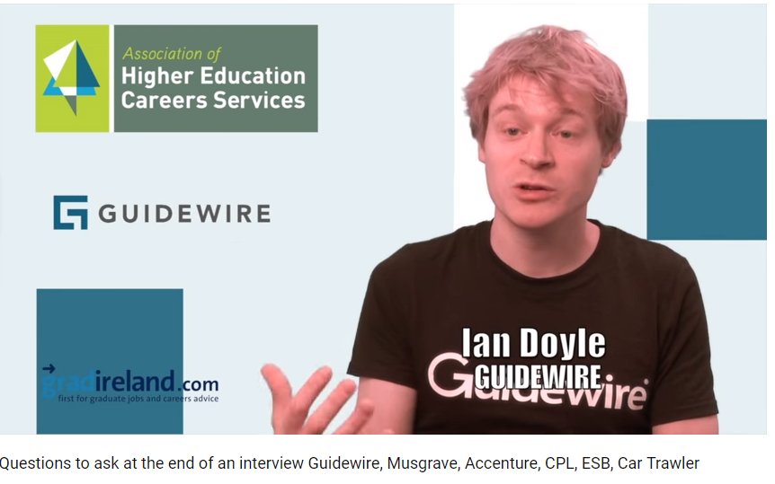
- Questions to ask at the end of an interview Guidewire, Musgrave, Accenture, CPL, ESB, Car Trawler - https://www.youtube.com/watch?v=s3PEqLYM7b8
__________________________________________________________________________________________________________________________________________________________________________________________________________________________________________________________________________________________________________________________________________________________________________________________________________________________________________________________________

- What do you want this person to have achieved in the first 3 months for you to feel they were successful?
- What do you think is the biggest challenge for a graduate in the first 3 months?
- What is a typical day like? How does that change from 1st to 3rd year?
- How are the teams structured – do trainees specialize in one sector or work across all sectors?
- Is there much collaboration across the different teams?
- What are the main priorities for someone in the first month?
- I have read xxxx about the CSR activities/social activities – what do graduates typically get involved with?
- What is the culture in the team like?
- What are the backgrounds of the people in the team?
- What is the next stage? When am I likely to hear back?

What shouldn’t you ask about?
- Things that you should already know from the job description or the website – they usually are very clear about the training and development on offer on the website.
- Money or benefits (Makes it look like that’s all you care about. Save this until after you’ve gotten the offer.)

Follow up note after the interview:
If you are interested in the role it is a good idea to send a follow-up thank you email within 24 hours. Communicate your enthusiasm for the job by restating your interest in the job and your conviction that you are the right fit for the position.

Competency Based Interviews – Using “STAR”

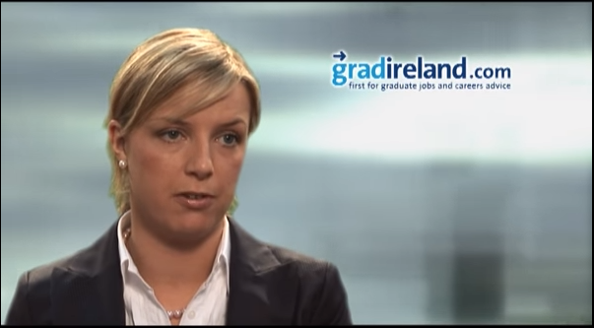
- Answering Competency Questions – Advice from PwC & KPMG https://www.youtube.com/watch?v=HsMJEvs5B8E&list=PL1C21DFE1FA4AF7F0&index=3

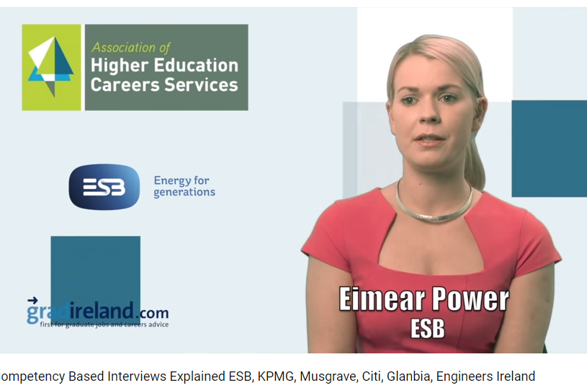
- Competency Based Interviews Explained: ESB, KPMG, Musgrave, Citi, Glanbia, Engineers Ireland https://www.youtube.com/watch?v=CwOjV7rtbjA

Step 1 – Situation or Task
Think of a situation similar to what the interviewer is asking you about that had a successful outcome.
Set the scene, giving brief context and background. Describe a specific situation that faced you or the task that needed to be accomplished.

Step 2 – Action
This is the most important and substantial section of the STAR approach (70% of your answer) as it is where you will need to demonstrate and highlight the skills and personal attributes that the question is testing. You have been faced with a big challenge: What did you do?
- Use the word I rather than we.
- Go into some detail explaining exactly what you did.

Step 3 – Result
The STAR story should end with a positive result - ideally one that can be quantified. Examples may include letters of commendation, exceeding targets by 15%, saving the team 10 hours a week.

The interviewer may also ask you what you learnt from that situation, and if there was anything you’d do differently the next time you were faced with that situation.

Practice an online video interview free of charge

(Free of charge for NCI students- available on both desktop or mobile)
Video interviews are becoming increasingly common. All candidates are sent a link with 4-5 interview questions that they can answer at their convenience.
- There is generally an opportunity to do a practice question but once the real interview begins, you can’t rewind or review your answers. You will generally have 20 seconds to read the question and one minute to answer it.
- Conduct the video interview in a quiet place.
- The interviewer will be able to see what is behind you so make sure the room is appropriate.
- Test the broadband, camera and microphone before starting the interview.
- Dress in interview attire.
- Some find talking to a blank screen off putting so it is worth practicing this beforehand.
- Self-recorded and YouTube video options tend to be used for sales, media or marketing roles. Candidates are invited to upload a film to showcase their personality and presentation skills.

If you have been invited to complete a video interview online (these are used by Musgrave, ESB, Bank of Ireland etc) we strongly recommend that you practice beforehand. NCI has invested in a one-way video interview tool for students and recent graduates. You will be asked to answer 4 questions (2 of which are competency questions).

Log onto: https://www.sparkhire.com/job/e95a1bc2-3eee-49c8-86b3-e9d835a0f82c

As this is a practice session and an opportunity for you to review and reflect on your performance, you will have unlimited time to review the first 3 questions

- 1.5 minutes to answer first 3 questions, will have unlimited takes before you submit first 3 questions.
- To simulate a real video interview the final question will allow you 30 seconds to review the question 1.5 minutes to answer the question and you will only have one opportunity to record yourself

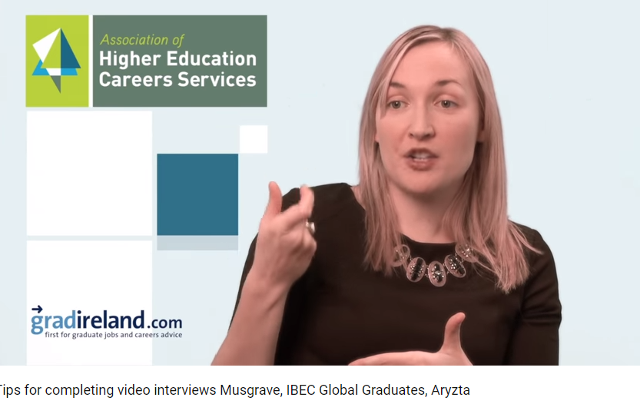
- Tips for completing video interviews Musgrave, IBEC Global Graduates, Aryzta https://www.youtube.com/watch?v=n8g4i5FFEQk

Telephone Interview Preparation – Tips

There is a growing trend for employers to use telephone interviews to pre-screen candidates.
- A telephone interview seems so informal it is easy to fall into the trap of not preparing for them as well as you would for a face-to-face interview however you need to prepare for a phone interview just as you would a regular interview.
- If you receive a call unexpectedly–explain you are unable to speak properly and arrange a time later that day to take the call. This way you will be prepared and more likely to make it to the next stage!
- Take the call in a quiet location where you won’t be interrupted and ideally use a landline.
- It is not only what you say but also how you say it that creates an impression of you. There are no visual clues unlike a face-to-face interview, so the tone and rhythm of your voice are very important - Smiling whilst you talk helps convey enthusiasm and energy.
- An advantage of a telephone interview is that you can have you CV and some notes in front of you. It is a good idea to have a short list of your accomplishments and ways in which you suit the role in front of you.
- Avoid the temptation to read from the notes. Lengthy notes can be quite distracting so if you are using some notes use a bullet point format.
- Be prepared for the usual interview questions – Initial telephone interview often are to check that you know what the role involves that you are applying for, that you meet the criteria and that you have an interest in the company you applied to.
- Consider standing throughout the interview. It will help you project energy and reduces the risk of sounding too casual over the phone.
- At the end of the call don't be afraid to let the interviewer know that it is a role you are really interested in and would welcome the opportunity to meet them face-to-face.
- Ask about the next steps so you know what to expect once you hang up the phone.

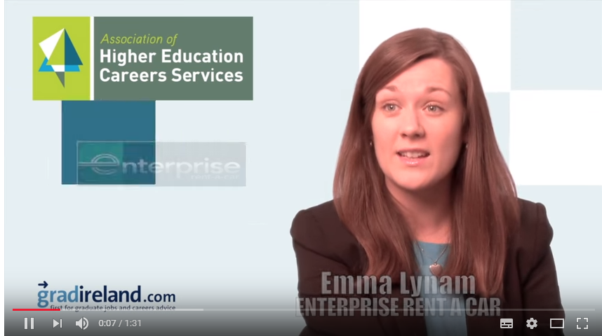
- Succeeding at telephone interviews Enterprise Rent a Car, CPL, Guidewire- https://www.youtube.com/watch?v=vxMJKuNvYrQ

Video Assistance for preparation

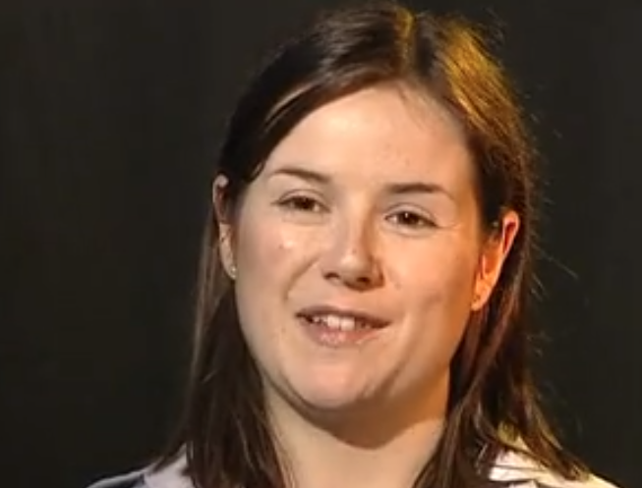
The graduate job interview at KPMG - http://vimeo.com/9996140

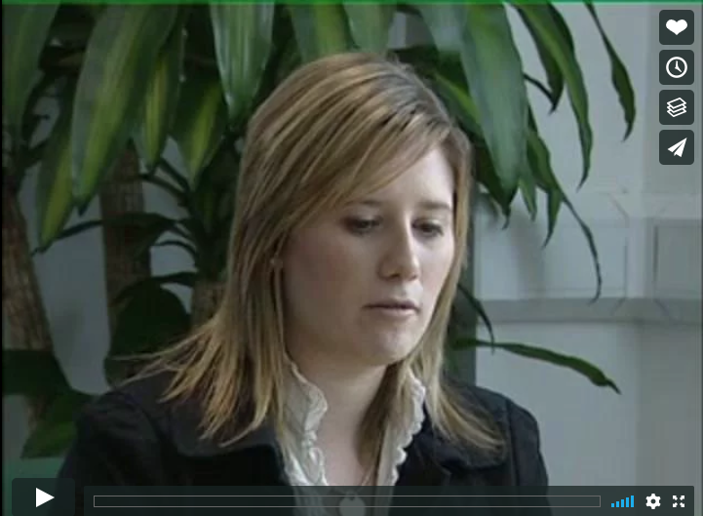
The Graduate job interview at Enterprise rent a car – http://vimeo.com/9995462

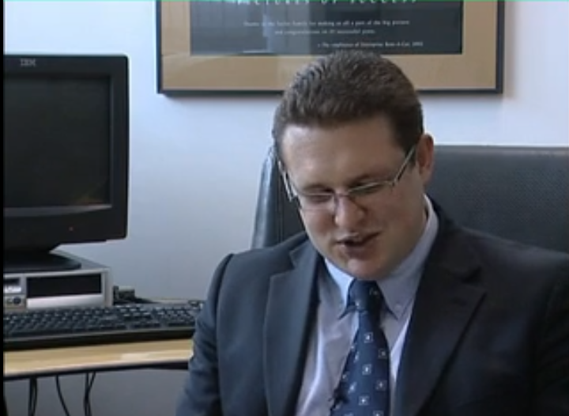
Enterprise Rent a Car Interview - Part 1http://vimeo.com/10190689

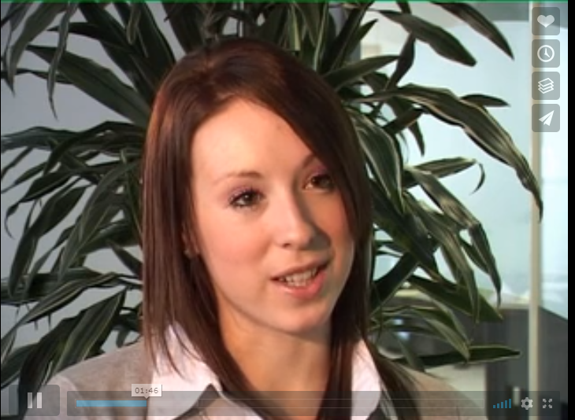
Enterprise Rent a Car Interview - Part 2- http://vimeo.com/10190772

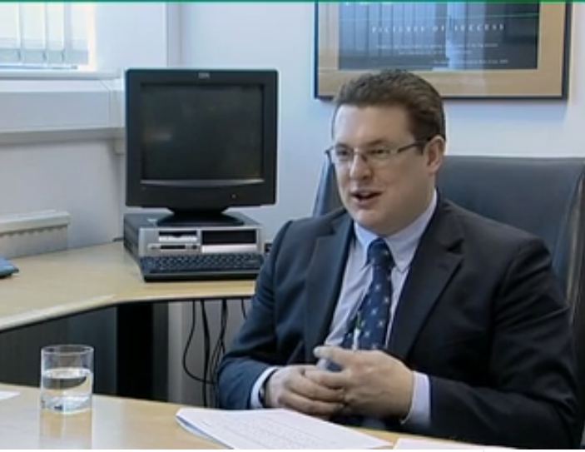
Enterprise Rent a Car Interview Part 3 - http://vimeo.com/10190825

